Provincial Towing Association (Ontario) Inc.
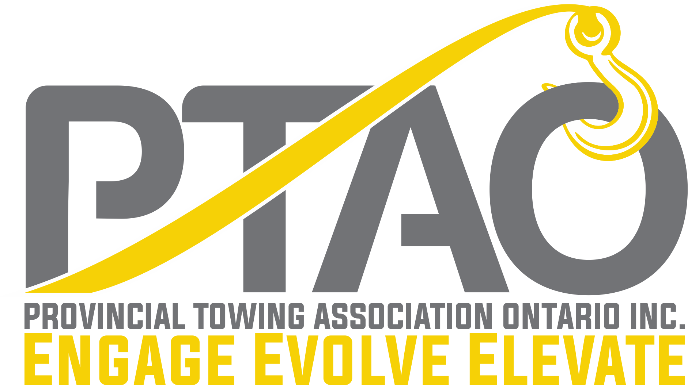
“The Association for Towing Professionals”
13775 HIGHWAY 17 EAST THESSALON ON P0R 1L0
Phone (705) 646-0536

MEMBERSHIP APPLICATION
Membership in Provincial Towing Association (Ontario) Inc. is open to all qualified towing companies engaged in the business of the transportation and recovery of motor vehicles within the Province of Ontario. Current membership dues are $500.00 + HST per PTAO business year. (Forms can be emailed to itowzm@cogeco.ca or faxed to 519-383-6167).
To become a member, complete and sign this form and return it to the PTAO office along with your cheque or credit card info for your dues for the year. We also accept E-Transfer. Please make cheques payable to Provincial Towing Association (Ontario) Inc. Membership renewal is October 1st of each year regardless of when you join up.
Company Name:

Owner/Officer - Full Name:____________________________________________________________

Street Address:______________________________________________________________________

Mailing Address (if different):__________________________________________________________

City/Town:________________________________ Province:______________________________

Postal Code:________________________ County or District:_________________________________
Business Phone: _____________________________ Fax:___________________________________
E-mail address:_______________________________ Web Site:_______________________________

Company Representative at Meetings:____________________________________________________

Alternate Representative:______________________________________________________________

Please list # of: Light/Medium Duty Wreckers ____ Light Duty Flatbeds ____ HD Tandem Rollbacks ____

Heavy Duty Wreckers _____ Rotators _____ Float Equipment ______ Other _________________________

I, the undersigned, do hereby agree to abide by the constitution and bylaws of the Provincial Towing Association (Ontario) Inc. I understand and agree that this membership can be terminated with or without notification to me for any violation of the bylaws or mission statement upon a majority vote of the Board of Directors. All decals and patches bearing the Association logo or insignia and the rights to reproduce the logo are the proprietary property of Provincial Towing Association (Ontario) Inc. Payments for decals or patches are a lease for the term of membership. Termination of membership terminates the right to use or possess any such PTAO sign, name or insignia in any form. The Association decal is a Service Mark Logo of Provincial Towing Association (Ontario) Inc., duly registered in the Province of Ontario.
Applicant's Signature:________________________________ Date:______________________
Cheque Enclosed [ ] E Transfer [ ]
Credit Card # __________________________________ Exp. __________AMEX [ ] MC [ ] VISA [ ]
Name on Card: ___________________________________________________ CVV __________

Office Use Only
Date of Application:_________________ Date Approved:______________ Date Paid:_________
Member Number:__________________ Zone:____________

