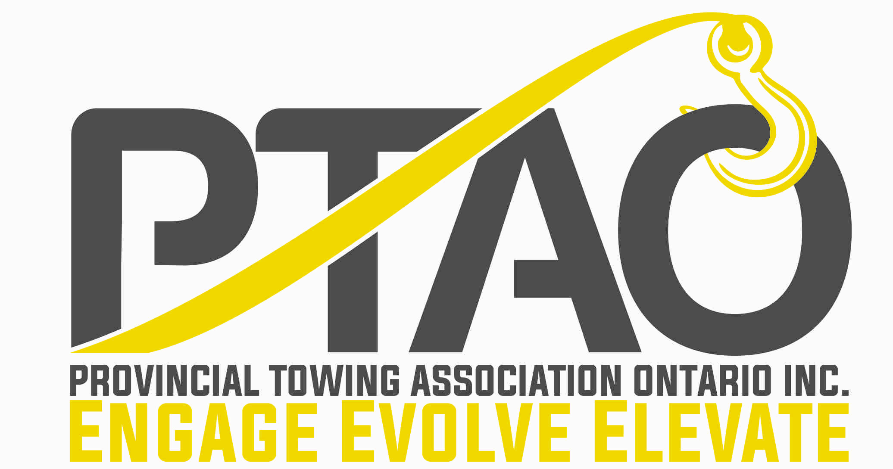

Benevolent Fund Application Form

Required submission materials:
• Application
• Letter of Request (see instructions in Part IV)
• Proof of Applicant’s Valid ID (copy of driver’s license)

Submission instructions: Please complete all required boxes of the application form. You may submit your application and letter of request via mail or email. Please choose only one of these methods and do not submit multiple copies.

Mail: Complete and return your application and letter of request – Provincial Towing Association of Ontario, 13775 Hwy 17 East, Thessalon, ON P0R-1L0

Email: You can submit the application and letter of request via email - you can scan your application, with the required signature, and email it to: info@ptao.org

PART I – Applicant Information

First Name:

Last Name:

Physical Address:

Mailing Address (If Different):

Phone Number: Cell Number:

Email:

PTAO Member: □ Yes □ No

PART II – Beneficiary Information (If applicable)

First Name:

Last Name:

Physical Address:

Mailing Address (If Different):

Phone Number: Cell Number:

Email:

Relation to Applicant:

PART III – Employer Information

Company Name:

Contact Person:

Physical Address:

Mailing Address (If Different):

Phone Number: Cell Number:

Email:

PTAO Member: □ Yes □ No

PART IV – Letter of Request

In order to complete the application process, applicants must submit a letter of request explaining the following:

1. Description of incident/situation including dates and locations
2. Explanation of financial need
3. Use of funds (if approved)

I understand that review by the Provincial Towing Association is confidential, and that its decision is final. I also understand that any award is discretionary, and that meeting the eligibility criteria does not guarantee an award. Should an award be made to me from the Provincial Towing Association of Ontario Benevolent Fund, I hereby agree to use the funds for the purposes as outlined in this application and accompanying letter of request, I also agree in advance to allow the Provincial Towing Association to list and publish the donation to me and my family as needed.

Privacy Information: Submitting information is strictly voluntary. By doing so, you are giving the PTAO your permission to use the information for the intended purpose. If you do not want to give the PTAO permission to use your information, simply do not provide it. However, not providing certain information may result in the PTAO 's inability to provide you with the services you desire.

Applicant Signature: | Date:

